Automatic Case Creation from Email
Dynamics 365 CRM – Configuration & Automation

1. Objective
The objective of this solution is to automatically create a Case in Dynamics 365 CRM when an email is received in the configured mailbox dev365admin@thomsonmedical.com.
If the sender does not exist in the system, Dynamics 365 automatically creates a Contact, and then the system creates a Case linked to that Contact.

2. Solution Overview
The automation process works as follows:
Customer sends email
↓
Email received in mailbox
↓
Email tracked to Dynamics 365
↓
Contact automatically created (if not exists)
↓
Power Automate Flow Triggered
↓
Case created in Dynamics 365

3. Deploy and Install Dynamics 365 App for Outlook
The Dynamics 365 App for Outlook allows users to track emails directly from Outlook into Dynamics 365.

Steps
- Navigate to Dynamics 365 Settings
- Open Dynamics 365 App for Outlook
- Add users who should have the Outlook integration enabled
- Click Add App to Outlook
This enables users to track emails into Dynamics 365 directly from Outlook.
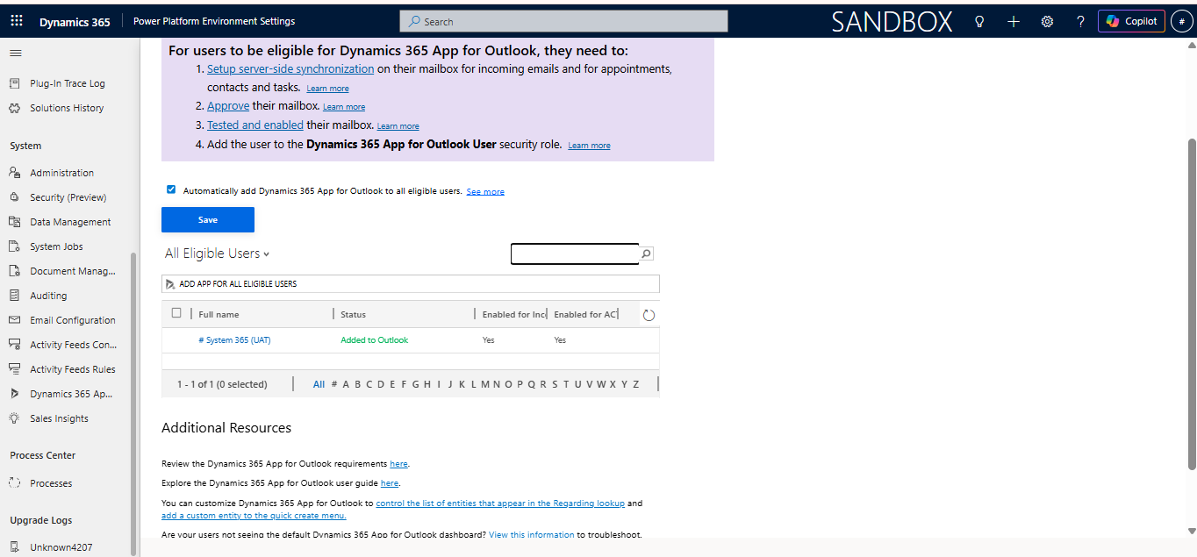Image 3.1- Outlook integration with CRM

4. Mailbox Configuration
The mailbox dev365admin@thomsonmedical.com is configured to allow Dynamics 365 to receive and process emails automatically.

Steps
- Navigate to
Advanced Settings → Email Configuration → Mailboxes
- Open the mailbox record for dev365admin@thomsonmedical.com
- Configure the following settings
Incoming Email → Server-Side Synchronization
Outgoing Email → Server-Side Synchronization
- Approve and test the mailbox.
- Ensure the status shows Success.
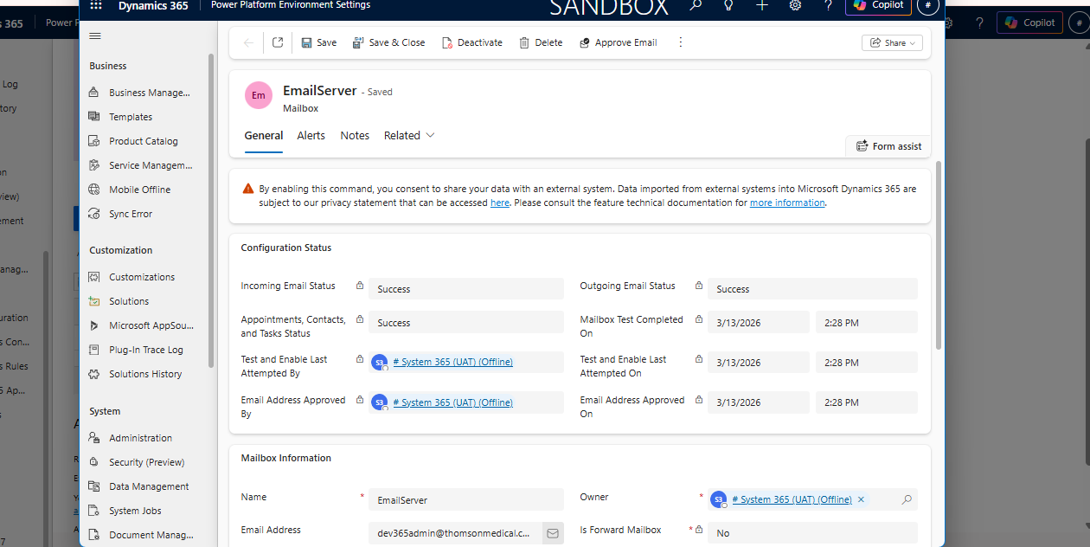Image 4.1 – Email Tracking Settings

5. Automatic Contact Creation
Dynamics 365 provides a built-in feature to automatically create contacts from tracked emails.

Configuration Steps
- Go to Settings
- Open Personal Options
- Navigate to the Email Tab
Enable the option:
Automatically create records in Microsoft Dynamics 365
Create → Contacts
When an email from a new sender is tracked, Dynamics 365 automatically creates a Contact record.
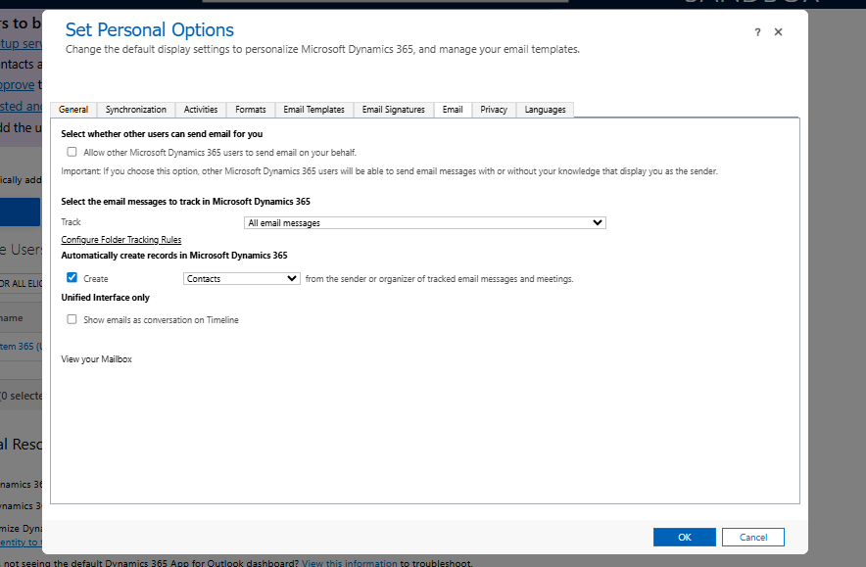Image 5.1 – Personalized setting for the contact record creation on incoming email

6. Case Creation and Power Automate Flow Configuration

Flow Logic
Email Received
↓
Power Automate Triggered
↓
Email Tracked to Dynamics 365
↓
Case Created
The flow creates a new Case (Incident) in Dynamics 365 using the information from the received email.
Case information includes:
• Case Title – Email Subject
• Customer – Contact reference created from email
• Description – Email Body
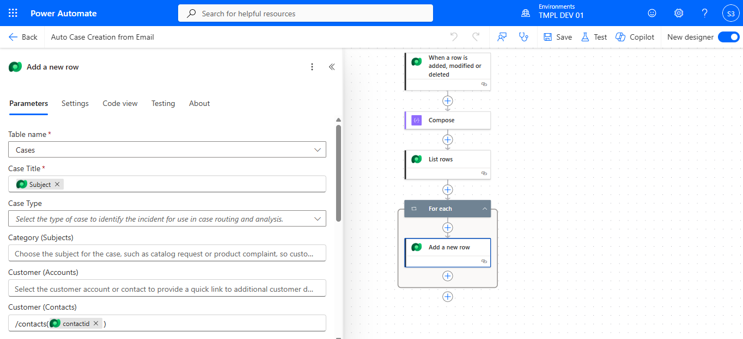Image 6.1 – Power Automate flow for case creation on incoming email in CRM

7. Result in Dynamics 365
After the automation runs:
- The email is tracked in Dynamics 365
- A Contact is automatically created (if not already existing)
- A Case is generated linked to that Contact
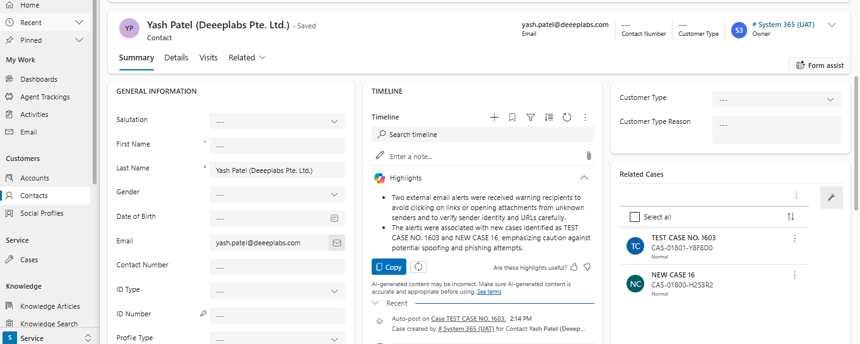Image 7.1 –Associated contact record created when the email is created in the system
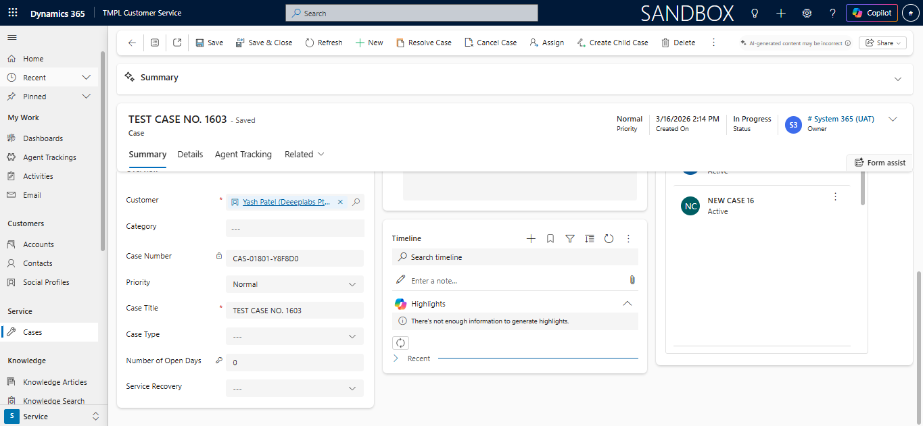Image 7.2 – Associated record of case created on incoming email in system

8. Conclusion
This automation improves customer service efficiency by automatically capturing customer emails and converting them into service cases in Dynamics 365.
Benefits include:
• Reduced manual work
• Faster response to customer emails
• Automatic contact management
• Improved case tracking

